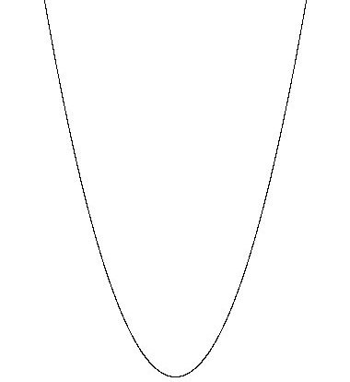
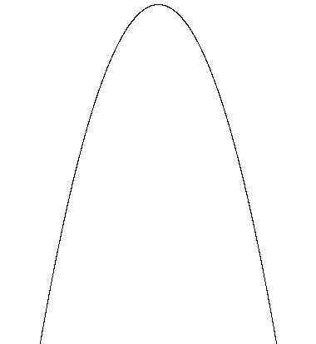
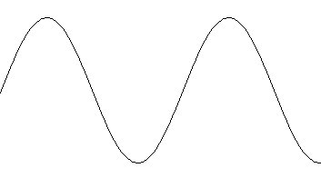
1. (a) (b) (c)
s
t
s
s
✓
✓
✓
✓
✓
✓
✓
✓
s
t
s
s
✓
✓
✓
✓
✓
✓
✓
✓
✓
v
t
v
t
v
t
✓
✓
✓
✓
(i)
(ii)
(iii)
(iv)
(v)
(vi)
✓
✓
✓

a
t
a
t
a
t
✓
✓
✓
✓
✓
✓
✓

Total 22 marks

2. (a) (i) s = 0, u = 10.0ms⁻¹, a = -9.8 ms⁻², t = ?
s = ut + $\frac{1}{2}$at²  
∴0 = 10.0t − $\frac{1}{2}$ × 9.8 t² ✓ = t(10.0 – 4.9t)  ✓
∴t = 0 or t = $\frac{\text{10}\text{.}0}{4\text{.}9}$= 2.0s (2 s.f.)  ✓
[3]
(ii) v² = u² + 2as
v = 0, u = 10 ms⁻¹, a = -9.8ms⁻²
∴0 = 10.0² – 2 × 9.8s  ✓
∴s = $\frac{\text{10}\text{.}0^{2}}{2×9\text{.}8}$ = 5.1m  ✓
[2]
t/ s
2.0
1.0
0
-10
10
v/ ms⁻¹
✓
✓
✓
(iii)
[3]
(iv)
[2]
t/ s
2.0
1.0
0
-10
10
a/ ms⁻²
✓
✓

Total 10 marks

3. (a) Vertical motion: s = ut + $\frac{1}{2}$at²
∴0.20 = 0 + $\frac{1}{2}$ × 9.8t²  ✓
∴t = $\sqrt{\frac{2×0\text{.}2}{9\text{.}8}}$= 0.20s  ✓
[2]
(b) Horizontal motion: u_{x} = $\frac{s}{t}=\frac{3\text{.}0}{0\text{.}\text{20}}$  ✓ = 15ms⁻¹  ✓
[2]
u_{x}
v_{v}
V
θ
(c)
Vertical final velocity: v_{v} = u_{v} + at = 0 + 9.8 × 0.20  ✓ = 1.96 ms⁻¹  ✓
Magnitude of total final velocity: V² = u_{x}² + v_{v}² ∴V = $\sqrt{{\text{15}}^{2}+1\text{.}{\text{96}}^{2}}$  ✓ 
V = 15.1 ms⁻¹ (15ms⁻¹ to 2 s.f.)  ✓
Angle: θ = tan⁻¹ $\frac{1\text{.}\text{96}}{\text{15}}$  ✓ = 7.4° below horizontal  ✓
[6]

Total 10 marks

4. (a)
v
t

General shape correct ✓
Ratios correct, 1 : ½ : ¼ ✓
Slopes parallel ✓
[3]
(b)
s
t

Parabolic curves ✓
Reducing in size ✓
Ratio of heights, 1 : ¼ : ¹/₁₆ ✓
[3]

Total 6 marks

5. (a) (i) Average speed = $\frac{1}{2}$(u + v)✓ = $\frac{1}{2}$(24 + 0) = 12ms⁻¹  ✓
[2]
(ii) $\frac{s}{t}$= $\frac{1}{2}$(u + v)
∴t = $\frac{2s}{u+v}$  ✓ = $\frac{2×\text{48}}{0+\text{24}}$ = 4.0s  ✓
[2]
(iii) a = $\frac{v^{2}−u^{2}}{2s}$= $\frac{0−{\text{24}}^{2}}{2×\text{48}}$  ✓ = - 6.0ms⁻² ✓
or: a = $\frac{v−u}{t}$ = $\frac{0−\text{24}}{4\text{.}0}$ ✓ = -6.0ms⁻²  ✓
[2]

(b) (i) u = 48ms⁻¹ a = -60ms⁻²
t = $\frac{v−u}{a}$ = $\frac{0−\text{48}}{−6\text{.}0}$  ✓  = 8.0s  ✓
[2]
(ii) s = $\frac{v^{2}−u^{2}}{2a}=\frac{0−{\text{48}}^{2}}{−2×6\text{.}0}$  ✓  = 192m  ✓
[2]

Total 10 marks

6. (a) s = v_{av} × t = 10 × 0.5✓ = 5.0m ✓
[2]

(b) (i) s = ?, u = 10ms⁻¹, v = 0, a = -5.0ms⁻²
s = $\frac{v^{2}−u^{2}}{2a}$ = $\frac{0−{\text{10}}^{2}}{−2×5}$✓ = 10m ✓
[2]

(ii) Total distance = thinking distance + braking distance = 5.0 + 10 = 15m ✓
[1]
v/ ms⁻¹
t/ s
0.5
2.5
10
✓
✓
(c)
Time to come to rest: t = $\frac{v−u}{a}$  ✓ = $\frac{0−\text{10}}{−5\text{.}0}$ = 2.0s  ✓
[4]
(d) Thinking distance = u × t = 12 × 0.5 = 6.0m  ✓
u = 12ms⁻¹, v = 0, a = -5.0 ms⁻², braking distance = s_{x}
s_{x} = $\frac{v^{2}−u^{2}}{2a}$ = $\frac{0−{\text{12}}^{2}}{−2×5\text{.}0}$ = $\frac{\text{144}}{\text{10}}$ = 14.4m  ✓
∴ Total stopping distance = 6.0 + 14.4 = 20.4m
∴ Car cannot stop  ✓ before reaching line and stops 0.4m past it.  ✓
[4]

Total 13 marks

7.
v_{v} = 50ms⁻¹

s_{v} = 500m

s_{x}

(a) u_{v} = 0 ms⁻¹, s_{v} = 500m, a = 9.8ms⁻² , t = ?
s_{v} = u_{v} + $\frac{1}{2}$at²
∴500= 0 + $\frac{1}{2}$× 9.8t²  ✓
∴t = $\sqrt{\frac{2´\text{500}}{9\text{.}8}}$ = 10.1s (10s to 2s.f.)  ✓
[2]

(b) v_{v} = u_{v} + at = 0 + 9.8 × 10.1  ✓ = 99ms⁻¹  ✓
[2]
u_{x}
v_{v}
v_{r}
θ

(c)

v_{r}² = u_{x}² + v_{v}²
∴v_{r} = $\sqrt{{\text{50}}^{2}+{\text{99}}^{2}}$  ✓ = 110ms⁻¹ (2s.f.)  ✓
θ = tan⁻¹ $\frac{u_{x}}{v_{v}}=\frac{\text{50}}{\text{99}}$  ✓ = 26.8° (27° to 2 s.f.)  ✓ [4]
[4]
(d) s_{x} = u_{x}t ✓ = 50 × 10.1 = 505m (510 to 2s.f.) ✓ [2]
[2]

Total 10 marks

8. (a) (i) OA: Constant velocity of 2.0ms⁻¹ (for 10s)  ✓
(ii) AB: At rest for 10s  ✓
(iii) BC: Acceleration from rest (for 5s)  ✓
(iv) CD: Deceleration to rest (for 5s)  ✓
(v) DE: At rest (for 10s)  ✓
(vi) EF: Constant velocity towards starting point (-3.3ms⁻¹ for 15s) ✓
(vii) FG: Constant velocity backwards from starting point (-3.3ms⁻¹ for 15s) ✓
(viii) GH: Constant forwards velocity (5.0ms⁻¹ for 10s) back to starting point  ✓
[8]

(b)
0
50
40
30
20
10
60
70
80
v/ ms⁻¹
t/ s
✓
✓
✓
✓
✓
✓
✓
5
-5
[7]

0
-50
50
50
40
30
20
10
60
70
80
s/ m
t/ s
A
B
C
D
E
H
G
F

Total 15 marks

9. (a) (i) Relative speed = 30 – 20 = 10ms⁻¹  ✓
∴time = $\frac{\text{100}}{\text{10}}$= 10s  ✓
[2]

(ii) Distance = actual speed × time  ✓
= 30 × 10 = 300m  ✓
[2]

(iii) Distance = relative speed × time  ✓
= 10 × 10 = 100m ahead  ✓
[2]

(b) (i) s = $\frac{v^{2}−u^{2}}{2a}$✓ = $\frac{0−{\text{30}}^{2}}{−2×1\text{.}0}$ = 450m ✓
[2]

(ii) Distance = lorry speed × time
Time to brake = $\frac{v−u}{a}=\frac{0−\text{30}}{−1}$ ✓ = 30s  ✓
∴Distance = 20 × 30 = 600m  ✓
[3]

(iii) Car starts braking 100m in front of lorry so comes to rest 100 + 450m,
ie. 550m ✓ ahead of lorry’s starting position.
In same time, lorry travels 600m.
So lorry is 50m✓ ahead of car when car comes to rest.
[2]

Total 13 marks

10.(a) (i) u=0, a = 9.8ms⁻², s = 4.9m
v² = u² + 2as = 2 × 9.8 × 4.9 ✓
v = 9.8ms⁻¹ ✓
[2]

(ii) s = ut + ½ at²
4.9 = 0 + ½ × 9.8 t² ✓
t = $\sqrt{\frac{2´4\text{.}9}{9\text{.}8}}$= 1.0s ✓
[2]
if speed ÷ 2
the KE ÷ 4 KE ∝ v²
so find PE ÷ 4
PE = mgs
∴ h ÷ 4.

Or
(b) (i) u = 9.8 / 2 = 4.9ms⁻¹
s = $\frac{v^{2}−u^{2}}{\text{2a}}=\frac{0−4\text{.}9^{2}}{−2´9\text{.}8}$✓ = 1.2m (2 s.f.) ✓
[2]
(ii) s = ut + ½ at²
0 = 4.9t - ½ × 9.8 t² ✓
0 = 4.9t(1 – t) ✓
t = 0, or t = 1.0s ✓
Or: Find time to top, t = $\frac{v−u}{a}=\frac{0−4\text{.}9}{−9\text{.}8}$ ✓= 0.5s ✓
Total time = 2 × 0.5 = 1.0s ✓
[3]

(c)
Velocity values correctly shown ✓✓✓, constant gradient between ✓
t/ s
v/ ms⁻¹
10
20
4.9
-4.9
-9.8
[4]

Total 13 marks

11.(a) u = 0, a = 10ms⁻² , t = 20s
v = u + at = 0 + 10 × 20 ✓ = 200ms⁻¹ ✓
[2]
(b) v² = u² + 2as
∴s = $\frac{v^{2}−u^{2}}{2a}$= $\frac{{\text{200}}^{2}−0}{2×\text{10}}$ ✓ = 2000m  ✓
Or: s = ½ at² = ½ × 10 × 20² = 2000m  
[2]
(c) Further height: s = $\frac{v^{2}−u^{2}}{2a}$ ✓ = $\frac{0−{\text{200}}^{2}}{−2×9\text{.}8}$ = 2040m (3 s.f.) ✓
∴Total height = 2000 + 2040 = 4040m = 4000m (2 s.f.) ✓
[3]

(d) v² = u² + 2as
∴v = $\sqrt{0+2×9\text{.}8×\text{4040}}$ ✓ = 280 ms⁻¹ (2s.f.) ✓
[2]

(e) Time to fall back to earth is: t = $\sqrt{\frac{\text{2s}}{a}}$ = $\sqrt{\frac{2×\text{4040}}{9\text{.}8}}$ ✓ = 29s (2s.f.) ✓
Time to reach max height after fuel used up is: t = $\frac{v−u}{a}$ = $\frac{0−\text{200}}{−9\text{.}8}$ = 20.4s ✓
∴Time for entire flight = 20 + 20.4 + 29 = 69.4s = 69s (2s.f.)✓
[4]

Total 13 marks

12.(a) (i) u = 0, s = 0.50m, t = 2.0 × 10⁻³s
$\frac{s}{t}$= $\frac{1}{2}\left(u+v\right)$  
∴v = $\frac{2s}{t}$ = $\frac{2×0\text{.}5}{2\text{.}0×{\text{10}}^{−3}}$ ✓ = 500ms⁻¹  ✓
[2]

(ii) s = ut + $\frac{1}{2}$at² u = 0
a = $\frac{2s}{t^{2}}$ ✓ = $\frac{2×0\text{.}\text{50}}{(0\text{.}\text{002})^{2}}$ ✓ = 2.5 × 10⁵ ms⁻²  ✓
[3]

(b) assuming constant deceleration
v² = u² + 2as

a = v² - u² but u = 0 so,
2s
✓
✓
a = v² = 500² = 5×10⁶ ms⁻²
2s 2×2.5×10⁻²
✓
F = ma = 10×10⁻³×5×10⁶ = 50kN
[3]

Total 8 marks

13.(a) (i) t = $\sqrt{\frac{2s}{g}}=\sqrt{\frac{2×\text{19}\text{.}6}{9\text{.}8}}$✓ = 2s ✓
[2]

(ii) v = u + at = 0 + (9.8 × 2)✓ = 19.6ms⁻¹ ✓
[2]

(iii) Distance travelled in first second: s = ½ gt² ✓ = ½ × 9.8 × 1² = 4.9m✓
∴Altitude = 19.6 – 4.9 = 14.7m✓
[3]

(iv) After one second, v = u + gt = 0 + (9.8 × 1)✓ = 9.8ms⁻¹ ✓
[2]

(e) Horizontal motion: s= vt = 0.5 × 2✓ = 1m ✓
[2]

Total 11 marks

14.(a) (i)
v/ms⁻¹
40
100
200 ✓
300
✓
✓
t/s
[3]
A
B

(ii) Distance travelled ✓
[1]

(iii) Area A = 2 × area B (same height, twice the base) ✓
Distance moved while acelerating = $\frac{2}{3}$ × total distance = 4000m ✓
[2]

(b) (i) Initial part v + u = v = $\frac{2s}{t}=\frac{2×\text{4000}}{\text{200}}$✓ = 40ms⁻¹✓
[2]

(ii) a = $\frac{v−u}{t}=\frac{\text{40}−0}{\text{200}}$  ✓ = 0.2ms⁻²  ✓
[2]

(iii) This will fall in acceleration phase 
Then v² = u² + 2as = 0 + (2 × 0.2 3000) ✓
∴ v = 34.6ms⁻¹ ✓ = 35ms⁻¹ (2 s.f.)
[2]

Total 12 marks

15.(a) u = 0 ✓ Thus: h = $\frac{1}{2}$gT²✓
[2] [2]

(b) Similarly 0.8h = $\frac{1}{2}$gt²✓
[1]

(c) t = T – 1
Thus from b) : 0.8h = $\frac{1}{2}$g(T₂ – 1)²  ✓
∴$\sqrt{\frac{1\text{.}6h}{g}}$ = T₂ – 1  ✓
From a: T₂ = $\sqrt{\frac{2h}{g}}$  ✓
∴$\sqrt{\frac{h}{g}}\left(\sqrt{2}−\sqrt{1\text{.}6}\right)$ = 1 ✓
Giving: h = 44.86g = 440m ✓
[5]

Total 8 marks

16.(a)
Distance/ m
0
2
4
6
8
10
12
0
0.5
1
1.5

Time/ s
Axes correct ✓ Points plotted ✓ Smooth curve ✓
[3]

(b) Increasing gradient ✓ ball accelerating ✓
[2]

(c) (i) Draw tangent at t = 0.6s ✓
Gradient = 6 ms⁻¹ (1 s.f.) ✓
[2]

(ii) Velocity of ball at time t = 0.6s ✓
[1]

(iii) g = $\frac{v−u}{t}=\frac{6−0}{0\text{.}6}$✓ = 10ms⁻² ✓
[2]

Total 10 marks

17.(a) (i) v = u + at
40 = 70 + 10a ✓
-3ms⁻² = a ✓
[2]

(ii) 70 = u – 3 × 10 ✓
u = 70 + 30 = 100ms⁻¹ ✓
[2]

(iii) s = $\frac{v^{2}−u^{2}}{\text{2a}}=\frac{0^{2}−{\text{100}}^{2}}{2\text{´-}3}$✓ = 1670m (3 s.f.) ✓
[2]

(iv) $t=\frac{v−u}{a}=\frac{0−\text{100}}{−3}$ ✓ = 33s ✓
[2]

(b)

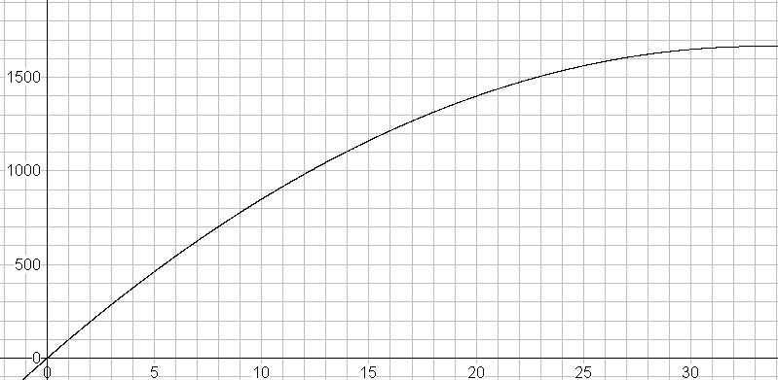
1670m
1500
1000
500
0

Distance/ m

0
5
10
15
20
25
30
Time/ s

Axes labelled with suitable values ✓
Start and stop points correct ✓
Two other points calculated, e.g. t = 10s, s = 850m and t = 20s, s = 1400m ✓✓
Smooth parabolic curve ✓
[5]

Total 13 marks

