F792 The Rock Cycle Exam Questions 2.1.1(a)

1. Fill in the product boxes on the diagram below.
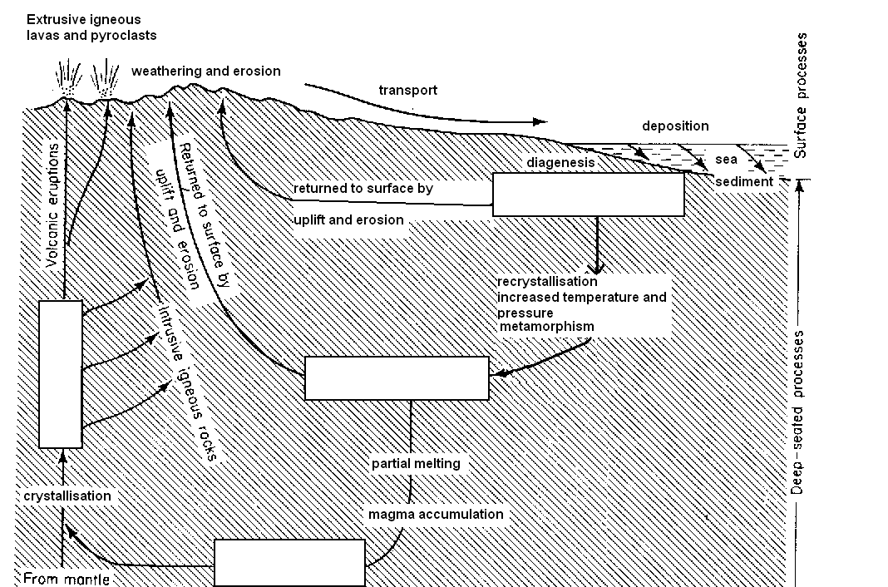

2. Complete the sentences below using the following terms
extrusive igneous intrusive lava magma metamorphic sediment sedimentary

(a) Rocks which crystallise from a magma form ......................................... rocks.

(b) Particles deposited as layers on the sea floor form ........................................ rocks

(c) Lavas and pyroclastic rocks cool to form ……….................. ........................ rocks.

(d) Rocks which have undergone recrystallisation form .........................................rocks.

(e) Rocks which have been weathered and eroded produce debris called ..........................

(f) Rocks heated under high temperatures and pressures produce

...................................... rocks.

(g) Magma intruded and cooled below the surface form ……………………………..

..................................... rocks

(h) Volcanoes are produced from ................................ which cools to form .....................

3. Complete the rock cycle below, inserting the appropriate name of a material in each of the boxes and a suitable process on each of the lines provided.
Process 4

__________________
Igneous rocks
Process 1: Weathering and erosion

Process 2

______________________
Process 3

______________________
Sedimentary rock

4. Name the energy inputs A and B on the diagram of the rock cycle below
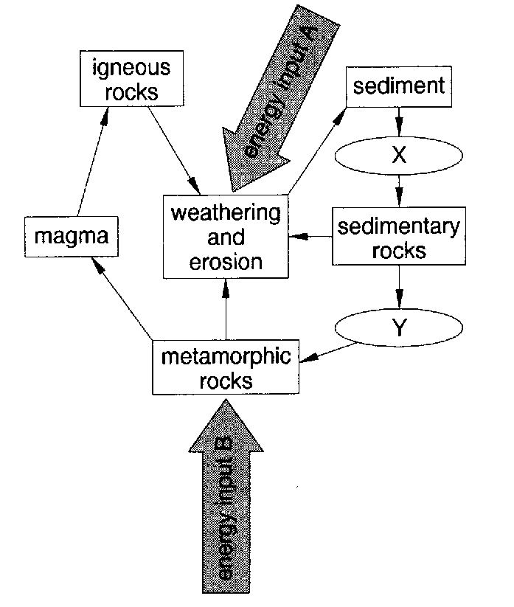
A ............................................................ B .....................................................

Name a process operating at

X ............................................................ Y .....................................................

5. Rearrange these process terms into the correct order to produce sedimentary rocks.
diagenesis erosion transportation deposition

.............................................................................................................................................

