Name ………………………………………………………… Marks

2 The lithosphere is broken up into tectonic plates.

(a) (i) Name the two main layers that make up the lithosphere.

........................................................................................................................................... [1]

- Name a plate that is composed largely of oceanic crust.

…………………….………………………………………………………………………………[1]

- Where is the lithosphere thickest?

………………………………………………………………………………...……………….....[1]

(iv) Where is the lithosphere thinnest?

……………… ………………………………………………………………………………….[1]

(b) The data below shows the increase in temperature with depth.

Depth / km | Temperature / ºC
0 | 10
50 | 900
100 | 1200
150 | 1400
200 | 1525
250 | 1600
300 | 1675
350 | 1700

(i) Plot a line graph of the data on the axes below. [3]
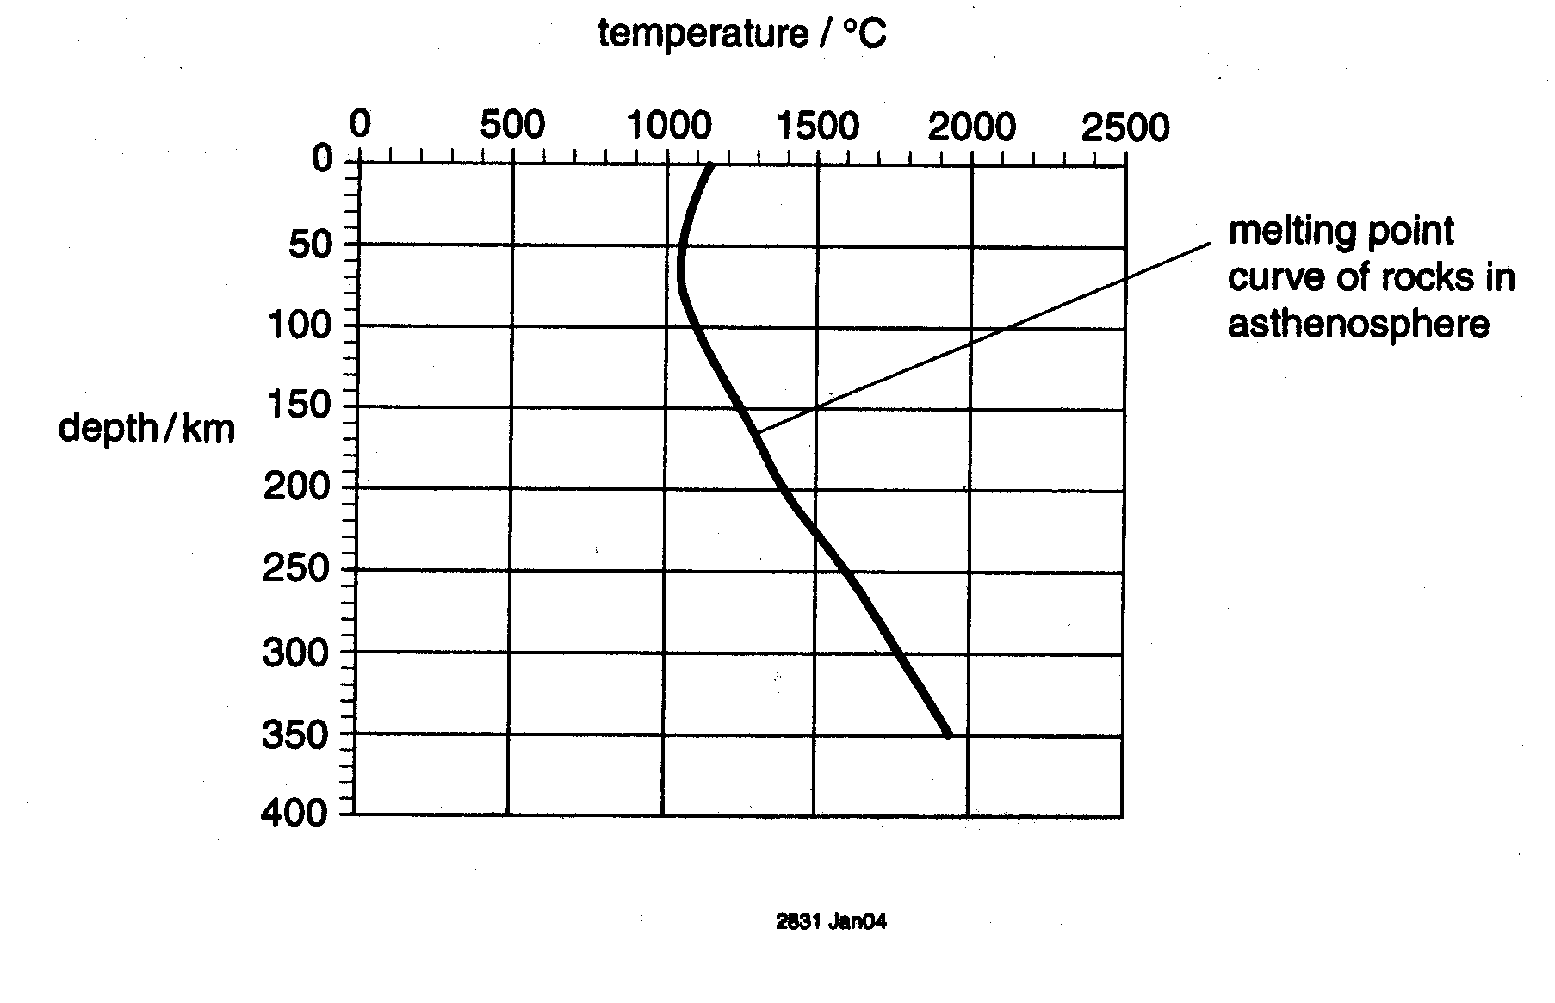

- What is this increase in temperature with depth called?

…………………………………………………………………..……………………………….[1]

(iii) Using the graph, state the depth for

the top of the asthenosphere …………………………..km

the bottom of the asthenosphere ………………………km [2]

(iv) Name the rock that is believed to form the asthenosphere.

………………………………………………………………………………………………….[1]

(v) State one reason why the asthenosphere has a lower earthquake wave velocity than the rest of the mantle.

………………………………………………………………………………………………………

…………………..............................................................................................................[1]

(c) (i) Complete the data grid below for the outer core and inner core of the Earth.

 | Inner core | Outer core
Depth below surface | km | km
composition
Physical state
[3]

(ii) Explain how density and meteorite data helps us to infer the nature of the inner and outer core.

…………………………………………………………………………………………………………

…………………………………………………………………………………………………………

…………………………………………………………………………………………………………

…………………………………………………………………………………………………………

…………………………………………………………………………………………………………

……………………………………………………………………………………………………….[3]

[Total: 18]

